<page_start no = 1>
<sol_start id=1>
1. (1) Tonoplast
<sol_end>

<sol_start id=2>
2. (4) Soluble starch
<sol_end>

<sol_start id=3>
3. (1) Haploid set of chromosomes
<sol_end>

<sol_start id=4>
4. (2) H₂O
<sol_end>

<sol_start id=5>
5. (3) K+
<sol_end>

<sol_start id=6>
6. (4) Hydathodes
<sol_end>

<sol_start id=7>
7. (1) Telophase
<sol_end>

<sol_start id=8>
8. (3) GS and gs
<sol_end>

<sol_start id=9>
9. (3) Overall, water molecules moves from left to right.
<sol_end>

<sol_start id=10>
10. (4) Hot, dry and windy
<sol_end>

<sol_start id=11>
11. (3) stuoma
<sol_end>

<sol_start id=12>
12. Asters (2)
<sol_end>

<sol_start id=13>
13. (2) sex chromosomes
<sol_end>

<sol_start id=14>
14. (4) 25% TT, 50% tT, 25% tt
<sol_end>

<sol_start id=15>
15. (4) stop growing and die gradually of starvation
<sol_end>
<page_end>

<page_start no = 2>
<sol_start id=16>
<sub_id = 1>
16. Mendel’s first law of inheritance are :-
Law of dominance : The first law of inheritance is law of dominance means which suppressed the receive then get dominant over it and expressed own character.
for example Tall plant (TT) cross over short plant (tt)
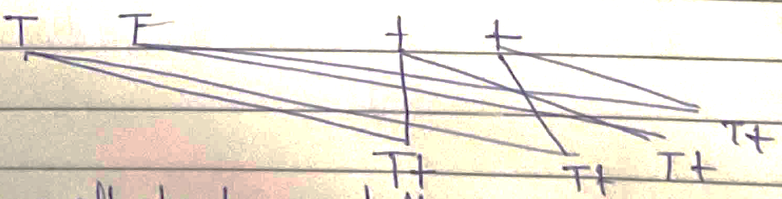
In f₁ phase all plants are tall.
<sub_id end>
<sub_id = 2>
(ii) 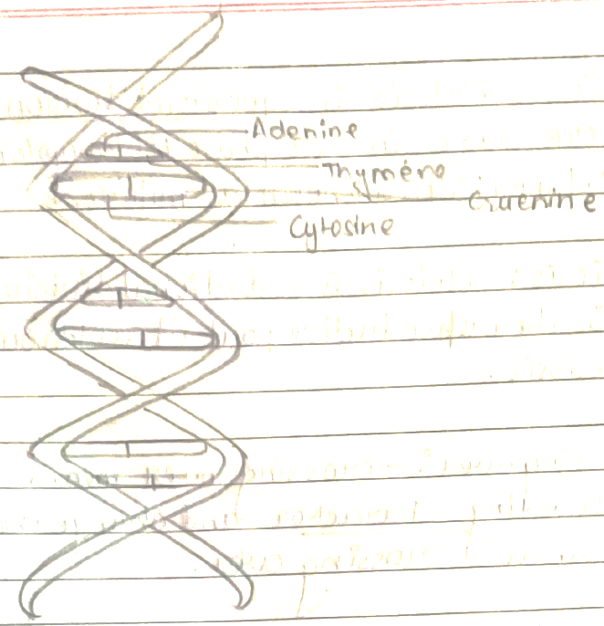
The DNA (Double helical model) of four nitrogenous product adenine, Thymine, Guenine and Cytosine.
Whereas Adenine made double hydrogen bond with Thymine (T) then, Guenine made thriple hydrogen bond with cytosine.
A = T
<sub_id end>
<sub_id = 3>
(iii) (a) The meaning of destarched plants is plant leaves without starch. It can destarched by the iodine solution.
(b) (i) Take a plants leaves without the presence of starch.
(ii) Then, cover a half part of the leaf the help of black strip.
(iii) leave the plants at the light place.
(iv) Then, use iodine solution where doesn’t not present starch it converted into Brown in colour.
<sub_id end>
<sub_id = 4>
(iv) (a) Mitosis : Mitosis is equational division and it completes there stage in two phase (i) karyokinesis (ii) cytokinesis it is known as mitosis.
(b) Meiosis : Meiosis is reductional division and present in the reproductive part it is known as meiosis.
(c) Crossing over : crossing over means crossing a contrasting character and change the genotypes is known as crossing over.
(d) Karyokinesis : Karyokinesis is division of nucleus and present in mitosis.
(e) Interphase : Interphase are resting phase of mitosis and involve three steps G, S and G₂ this known as interphase.
<sub_id end>
<sol_end>

<sol_start id=17>
<sub_id = 1>
17. (i) open stomata
<sub_id end>
<sub_id = 2>
(ii) A-epidermis B-Guard cell C- stomata O-nucleus
<sub_id end>
<sub_id = 3>
(iii) During transpiration stomata will open and give a coating effect the surface area of leaf on other hand during photosynthesis stomata will closed.
<sub_id end>
<sub_id = 4>
(iv) The function of stomata are followed :
⇒ It regulates the exchanges of gases (CO₂ and O₂)
⇒ It maintain the concentration level of water.
<sub_id end>
<sub_id = 5>
(v) Three kind of transpiration are :
⇒ Stomatal transpiration :- Transpiration through minute opening of stomata in the leave is known as stomatal transpiration.
⇒ Cuticles transpiration : Transpiration through cuticles present on the leaves is known as cuticular transpiration.
⇒ Lenticular transpiration :- Transpiration through old barle tree present at the stem is known as lenticular transpiration.
* Minimum transpiration – lenticular
* Maximum transpiration – stomatal
<sub_id end>
<sol_end>
<page_end>

<page_start no = 3>
<sol_start id=18>
<sub_id = 1>
18. (i) Prophase
<sub_id end>
<sub_id = 2>
(ii) Centromere, (2) chromatids, (3) spindle fibre
<sub_id end>
<sub_id = 3>
(iii) 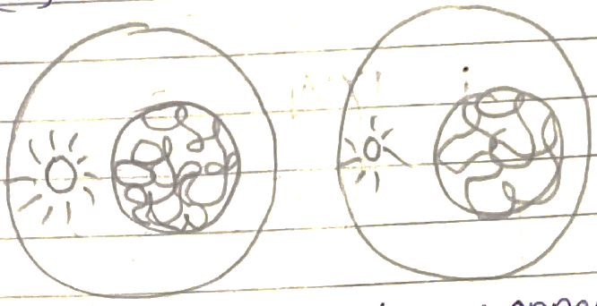
nuclear membrane appear
<sub_id end>
<sub_id = 4>
(iv) (a) mitosis division
(b) meiosis division
<sub_id end>
<sub_id = 5>
Mitosis | Meiosis
* 2 daughter cell produced | * 4 daughter cell produced
* equcational division | * reductional division
*It present somatic ang vegetative part | *It present on reproductive part.
*It is diplode | *It is haploid
(v)

<sub_id end>
<sol_end>
<page_end>

<page_start no = 4>
<sol_start id=21>
<sub_id = 1>
21. (i) A – hypotonic solution
B – hypertonic solution
<sub_id end>
<sub_id = 2>
(ii) A – deplasmolysis
B – plasmolysis
<sub_id end>
<sub_id = 3>
(iii) hypotonic (cell A)
Hypertonic (cell B)
<sub_id end>
<sub_id = 4>
(iv) Osmotic pressure, root pressure
<sub_id end>
<sub_id = 5>
(v) The path of ascent of sap are :
Cohension : water molecules attached with water molecules.
Adhension : water ,p;eci;es attacjed wotj ptjer sibstamce.
Root pressure : The pressure exerted by the root for the movement of water molecules.
<sub_id end>
<sol_end>
<page_end>

